**Step 1: Request records from MARCIt**

MARCIt! is a records service from SFX to furnish MARC records for e-journals currently active in SFX. We get new records as well as updates to existing records and records marked for deletion. MARCit updates happen weekly, so updates are ready to download every Monday.

Log into SFX as usual and select MARCIt! Tool under **Setup & Administration** in the list of **Additional KB Tools**. At the welcome screen choose **Use a MARCIt! Profile** (first of two options). You’ll need to adjust #1 and #3 each time you request records:

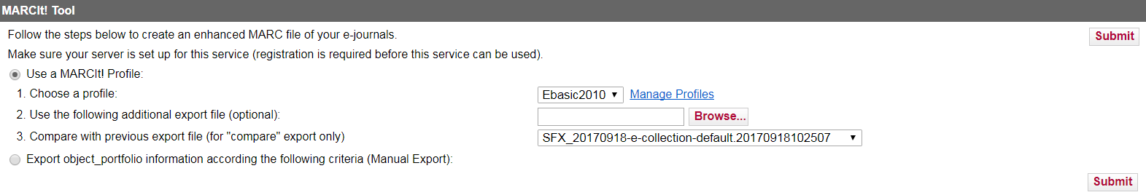

Option 1 is a drop-down with **Ebasic2010** as the default choice. Leave it as is, but click on **Manage Profiles**, then click on **E** to edit.

Towards the bottom of the screen, there’s a field marked **Specify export file prefix**. It reads as “SFX_“ followed by a date, and is gets added to a file name to make it more eye-readable. After the underscore in the prefix, enter today’s date (YYYYMMDD) and click **Save Profile**. Keep this export prefix in mind, as you’ll be using it throughout the process to identify the file you’re working with.

Once back on the profile selection screen, close it and return to the main menu of the MARCIt Tool. Once there, select **Use a MARCIt! Profile** again and click on the dropdown for option 3. You’ll see a list of long file names with export prefixes containing earlier dates; they’ll appear as:

[export prefix]-e-collection-default-[YYYYMMDDHHMMSS of file generation]

Now choose the file name with the most recently dated export prefix. This will be the file that MARCIt compares to its current data in order to which records have changed since then. Click **Submit** to request a file of MARC records. You will receive an e-mail, usually in under 30 minutes, when they are ready to retrieve via FTP.

**Step 2: Download MARCIt! files from the SFX server**

Once the records are ready, you will need to retrieve them from the MARCIt server via FTP. Open the SSH Secure Shell Client and log in using the SFX MARCIt profile. The password is 2015Tul@n3.

Type ls or dir to get a list of files in the FTP directory. You’ll see a long list of files, and towards the end of the list you’ll recognize files with the export prefix you edited when you were using the MARCIt tool. Find the files with the prefix you’ve recently added. They’ll look something like this:



Find the file name with the right prefix and with the file extension **MARC.tar.gz**; this is a zip file containing all the MARC records you’ve requested plus a couple of other files you’ll need. Highlight the file name and right click to copy.

At the command prompt, type: tar –xzf [then right-click to paste in the file name]

This will extract the files. Type dir or ls and check towards the end of the list, they’ll look something like this:

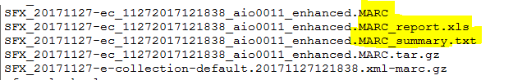

You’ll need the .MARC file plus the Excel and text files. In order to download them, click on the File Transfer icon:

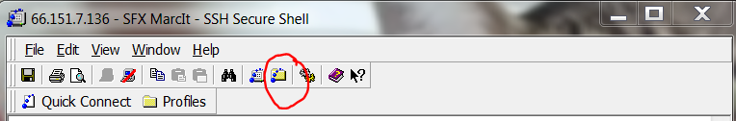

A new window will pop up and show two file structures side by side. The left-hand one is your local system, and the right is the SFX server. In the local system, navigate to the **HT Bulkloads** shared folder, then go to **\MarcIt\01FilesToLoad_Current\**.

Next, on the SFX server, scroll down until you find the files with the current export prefix (the one you assigned back in Step 1). Select the .MARC file, the Excel file, and the text file. Right-click and select **Download** from the context menu. They’ll appear in the local directory on the left-hand panel. Once you have them, disconnect and close both the file transfer and the shell clients.

**Step 3: Batch editing with MarcEdit**

Now that you’ve downloaded the files, you’re ready to edit them. Open MarcEdit and select MARC Tools to convert the MARC file to an editable format.

Under input file, click on the folder icon and browse to the .MARC extension among the ones you just downloaded to **\MarcIt\01FilesToLoad_Current\**. When selecting the name for the Output File, you can truncate the file name if that makes it easier to work with. As long as you keep the export prefix and some phrase to indicate that this is the file you’re editing, it will be identifiable. Be sure to check **Translate to UTF8** or else diacritics won’t display correctly and will make most non-English text look like gibberish.

The following steps in MarcEdit will cover the processes and automated tasks for editing these bib records, in some cases adapting records for print resources to describe electronic ones instead. These instructions don’t go into detail about MarcEdit functionality or the cataloging principles behind the edits.

First, delete any existing 998 fields (there aren’t usually many). Next, use the **Select Records for Edit** function to pull out fields with certain contents. Follow the steps outlined in the figure below:

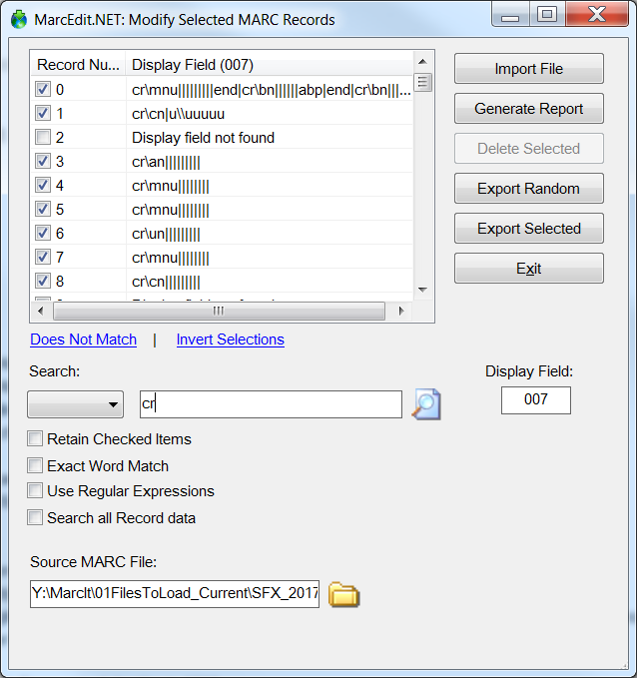

Step 2: Click to show the selected display field for all records.

Step 1: Enter the desired display field.

Step 4: Export checked items to a temporary file for editing. Save file to add selections back to original file.

Step 3: Enter character or string to search in the display field. Results will appear checked.

The selected records will open into a new, temporary file and can be edited. Go to **Tools** and select **Assigned Tasks**. Select: **998 online per 007cr statement**. Save the selected records back into the main file (do not use Save As). Saving closes the editing screen, you’ll need to re-open the file in Editor.

For your next steps, you’ll be selecting records, running tasks, and saving them back to the main file. Follow the next seven steps as outlined in this table. Unshaded tasks are run within the entire file.

|  |  |  |  |
| --- | --- | --- | --- |
| Display Field | Search term | Tools 🡺 Assigned Tasks | Next step |
| 338 | online | 998 online per 338 statement | Save back to main file and proceed |
| Run task within main file: **998 add $a only** | | | Save and proceed |
| Run task within main file: **008-39 _SourceCodeD** | | | Save and proceed |
| 008 | _ [underscore] | Non-pcc 998$c addition | Save back to main file and proceed |
| Run task within main file: **pcc 998$c addition** | | | Save and proceed |
| Run task within main file: **Remove 008-39_SourceCodeD** | | | Save and proceed |
| 998 | CONSER | Go to **Edit** and **Find** term “source record is online” | Note the number of records at the top of the search results list. Record on stats spreadsheet as CONSER-E. |

Once you’ve noted the number of records in the final step, close the temporary file without saving, and re-open the main file. The next series of edits requires some examination, judgment, and possibly editing by hand.

Accompanying materials (rarely occurs now): Check for records for formats other than print or electronic. From the File dropdown, pick **Select Records for Edit,** enter the **Display Field** as 300$e, and check for the presence of any $e. Usually, there aren’t any, but if you do find any, sort out those records and remove any fields or subfields that refer to them.

This also rarely happens, but if a record appears to be a description of a CD-ROM version of a serial (i.e., CD-ROMS are noted in $a rather than $e), make the following edits: change the 300 field to 300 \\$a1 online resource. Change 010 $a to $z. Change 998 $a to read MARCit from CD-ROM.

Records based on microform format: A more frequent occurrence is records based on microform, either as a reproduction or republication of title that was originally print. To check for them, go back to the **Select Records for Edit** feature and enter 337 as the display field. Import the file and then enter “microform” as the search term. If there are any results, the records should be examined, so click on **Export Selected Records**.

Run the task named **300 online resource**.

Delete any 533 fields (Reproduction Note). KEEP the 534s (Original Version Note). Save back to the main file. Now go back to Select Records for Edit, enter 534 as the display field, import the file, and enter “not found” as the search term. *Invert* that selection, Export Selected Records, and run the task **010a to 010z**. Save these records back to the main file.

Now run **Edits for all MARCit records**.

Go to **Select Records for Edit** again. Enter 998 in the display field, Import File, and search for “online”. Once those results appear as checked boxes, click on **Invert Selections**. (You’re editing records based on descriptions of print titles, so you want all the records that *aren’t* for online resources.) Export the selected records and run the task called **MARCit from Print edits**.

Save back to the main file and run the task: **Add GMD back in**.

**Do one final field sort by hitting CTRL + F11**. MARCEdit doesn’t do this automatically, and neither does Voyager. If the fields in your records are not in order when you save your file back into MARC format, they’ll go into Voyager with fields out of order.

Now compile the file back into MARC via the command on the button bar or the File dropdown menu. Be sure that you’re saving it as UTF-8 MARC file; you may want to alter the file name slightly so that you know it’s the final, ready-to-upload version.

**Step 4: Upload to Voyager Web Server**

Log into Voyager Web Server at voyager.tcs.tulane.edu/webadmin. Go to Bulk Import MARC Records. Select your file and put these settings into the Voyager Batch Upload Information section:

Import Code: SFX

Operator Name: use yours

Generate Keyword INDEX: check this box

Show/Approve MARC display before database load: check this box

Allow multiple instance of bulk import: check this box

Enter your e-mail address and Submit Batch Report as usual. Look over the report and check basic details. Diacritics and non-Roman characters may not display correctly in your browser. (That’s why it’s important to ensure that your file is a UTF-8 MARC file while working in MarcEdit – there’s no way to confirm it by looking at the display in this step.) If everything looks okay, click **Accept these records**.

Within a few minutes you’ll get a couple of e-mails confirming that the process has started and finished. The “bulkimport COMPLETED” e-mail should have an attached zip file. You’ll need to keep the load reports for a while, so create a folder where you can save them and unzip them.

You can view your files in Notepad++ by right-clicking and selecting that option from the context menu. The vast majority of uploads happen with no complications, so all you need to do is scroll to the bottom and check the totals for records processed, added, and replaced. If you do see any numbers for records discarded, rejected, or errored, ask for guidance.

**Step 5: Delete Records**

From the main screen of Access, select C: Voyager9 Access Reports.

You’ll see a left-hand panel displaying a list of tables, queries, or whatever was selected when you last closed Access. Use the arrow beside the list header and select Queries. Pick **qryMARCitDELETES** (or the similar local name you’ve used) and click yes on the three pop-ups requesting confirmation.

Now switch over to Tables and find **tblMarcIt_Deletes** (or the similar local name you’ve used). Double click it to bring up a table of data generated by the query you just executed. Select and copy the first column (BIB_ID); paste it into Notepad. Delete “BIB_ID” -- the column label – from the list so that you have only a list of numbers. Also verify that there is no extra return at the end of the list. Save this file with an intuitive name into folder that’s easy to navigate to and identify.

Now close Access and Notepad, and open BibDelete. Adjust settings to what you see below if the program doesn’t default to them. Use Browse to navigate to the text file you just saved. Do not alter the settings are you see them here (ignore the blue highlighted field):

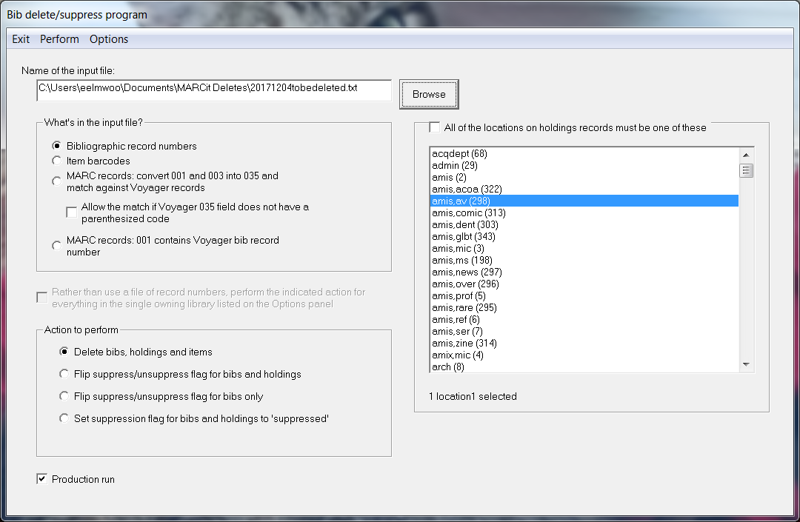

Hit Perform and let the program run. If you are deleting a large file (100+) records, it will take several minutes to delete them all.

**Appendix: Checking Your Work in MARCEdit**

There are a few different sorts and searches you can do to make sure your edits have taken effect and are correctly formatted.

**Field Count**

Under **Reports 🡪 Field Count**, you can get a count of every field occurring in your file and the number of times it occurs. For a total number of records in a file, look for the count under a non-repeatable field like 245.

**Edit 🡪 Find All (Ctrl + F)**

If you’re checking to make sure one field is identical or at least uniform in all records (e.g. 336), this can be quick way to spot any irregularities:

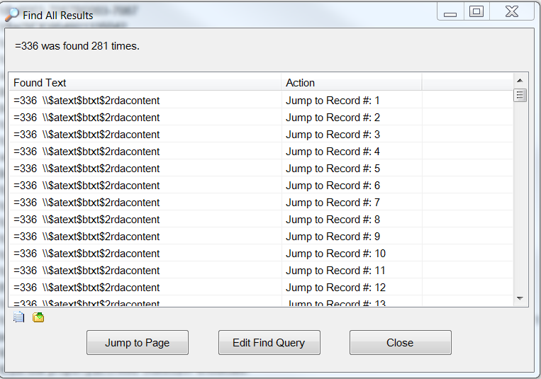

Clicking on the Found Text bar will sort the results in reverse order. This feature is most useful with a smaller sets of results where the fields and subfields usually don’t vary much. To do another search, click on Edit Find Query.

This search feature also works well if you’re looking for uncommon/unique strings of text or subfields.